World Remit Processor
Integrating to IMT Core

Design Specification Document

Date: 13th July 2020
Version: 1.0.0

Revision History
Date | Version | Description | Revised By
13th July 2020 | 1.0.0 | Initial Draft | Shadrack Mwagiru

Sign Off required
Name | Position | Signature | Date
Shadrack Mwagiru | Head of Enterprise Architecture
Egbe Udop | InfoSec Security Architect
Sammy Njoroge | Senior Network Engineer
Kelvin Makau | Team Lead – IT Operations
Nathan Njuguna | Head of database & Datawarehouse Engineering
John Muli | Head of Integration development

Proprietary Notice

This document contains information specific and confidential to Equity Ltd.

Table of Contents
Introduction 4
Overall Sequence flow 6
Webhook specification 8
Webhook registration 8
Webhook calls to Equity 9
Transaction awaiting API specification 10
WorldRemit and IMT remittance API mapping 19
Transaction set paid specification 24
Transaction set failed 27
Data architecture 28

Introduction
Target Audience
This document aims to provide guidance to software developers, project and product managers, software quality assurance, release managers, DevOps engineers, infrastructure, security and solution architects in the implementation, deployment and management of the solution. This design conforms to and relies heavily on the existing enterprise architecture, development and operations principles.
Project Scope
This document outlines the following:
- Proposed solution in reference to the business requirements
- Software architecture defining the various software components, enterprise integration patterns and dependencies
- Data architecture defining the various payloads, protocols, data structures and entities to maintain
- Deployment models detailing how the solution will work in the production environments considering cloud and on-prem servers
The following modules are proposed to realize the requirements in reference:
- World remit processor
- Internal integration to IMT core

Design Constraints, Assumptions, Dependencies and Risks
Assumptions
- Existing developer account with world remit
- Existing integrations with the core banking system, M-Pesa and Pesalink via the OMNI channel

Dependencies Within Scope
To fully achieve the above modules, the following enhancements are required to the existing applications:
- Internal international money transfer (IMT) core
  - IMT core also relies on integrations with the banking system, mobile money systems like M-Pesa, interbank transfer systems like Pesalink and the Equity bank’s internal wallet
Risks
- Network latency and connection failures between micro services
- General system unavailability

Proposed Solution
World Remit Processor
- Webhook service - This gets called by World Remit notifying the processor that there are some pending transactions
- Pull service - Fetch pending transactions publishing them in a local queue
- Process service - Consume transactions in a local queue pushing them to IMT core publishing statuses for each in a response queue
- Notification service - Sending status back to World Remit from the response queue
- Transaction status service - This is a synchronous service which World Remit will call to check the status of a transaction being processed internally

High Level Architecture
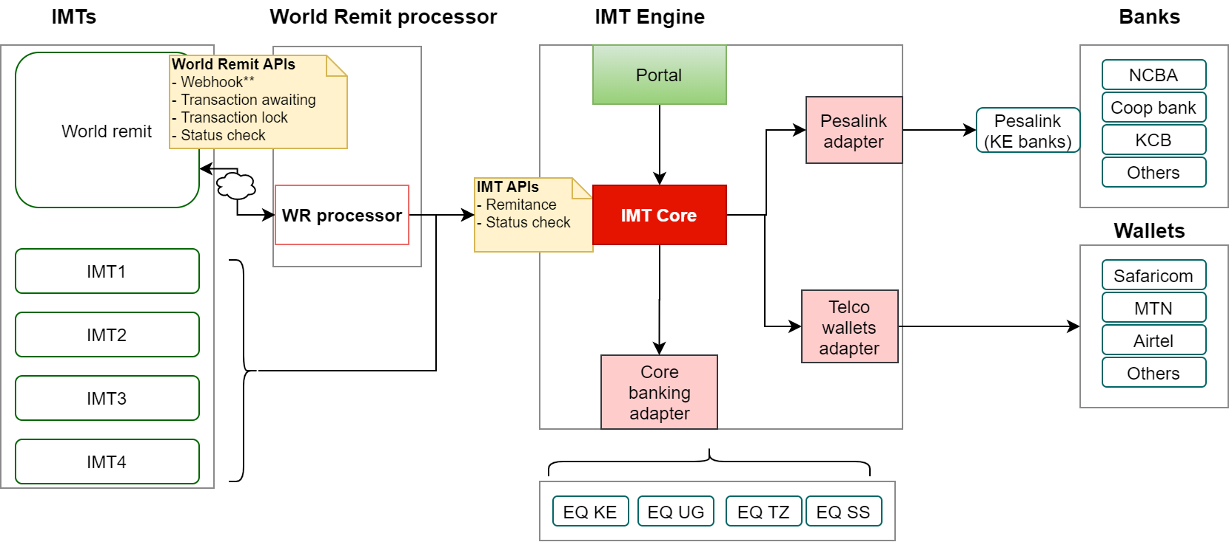
Architecture Description
- A payment is booked by a world remit customer – this might call the validation API if it is enabled
- World remit sends notifications to the processor for pending requests
- Processor pulls requests and sends them to the IMT core
- The IMT core calls the relevant service to finalize the money transfer
- The processor notifies World Remit API sending the transaction processing status

Overall Sequence flow
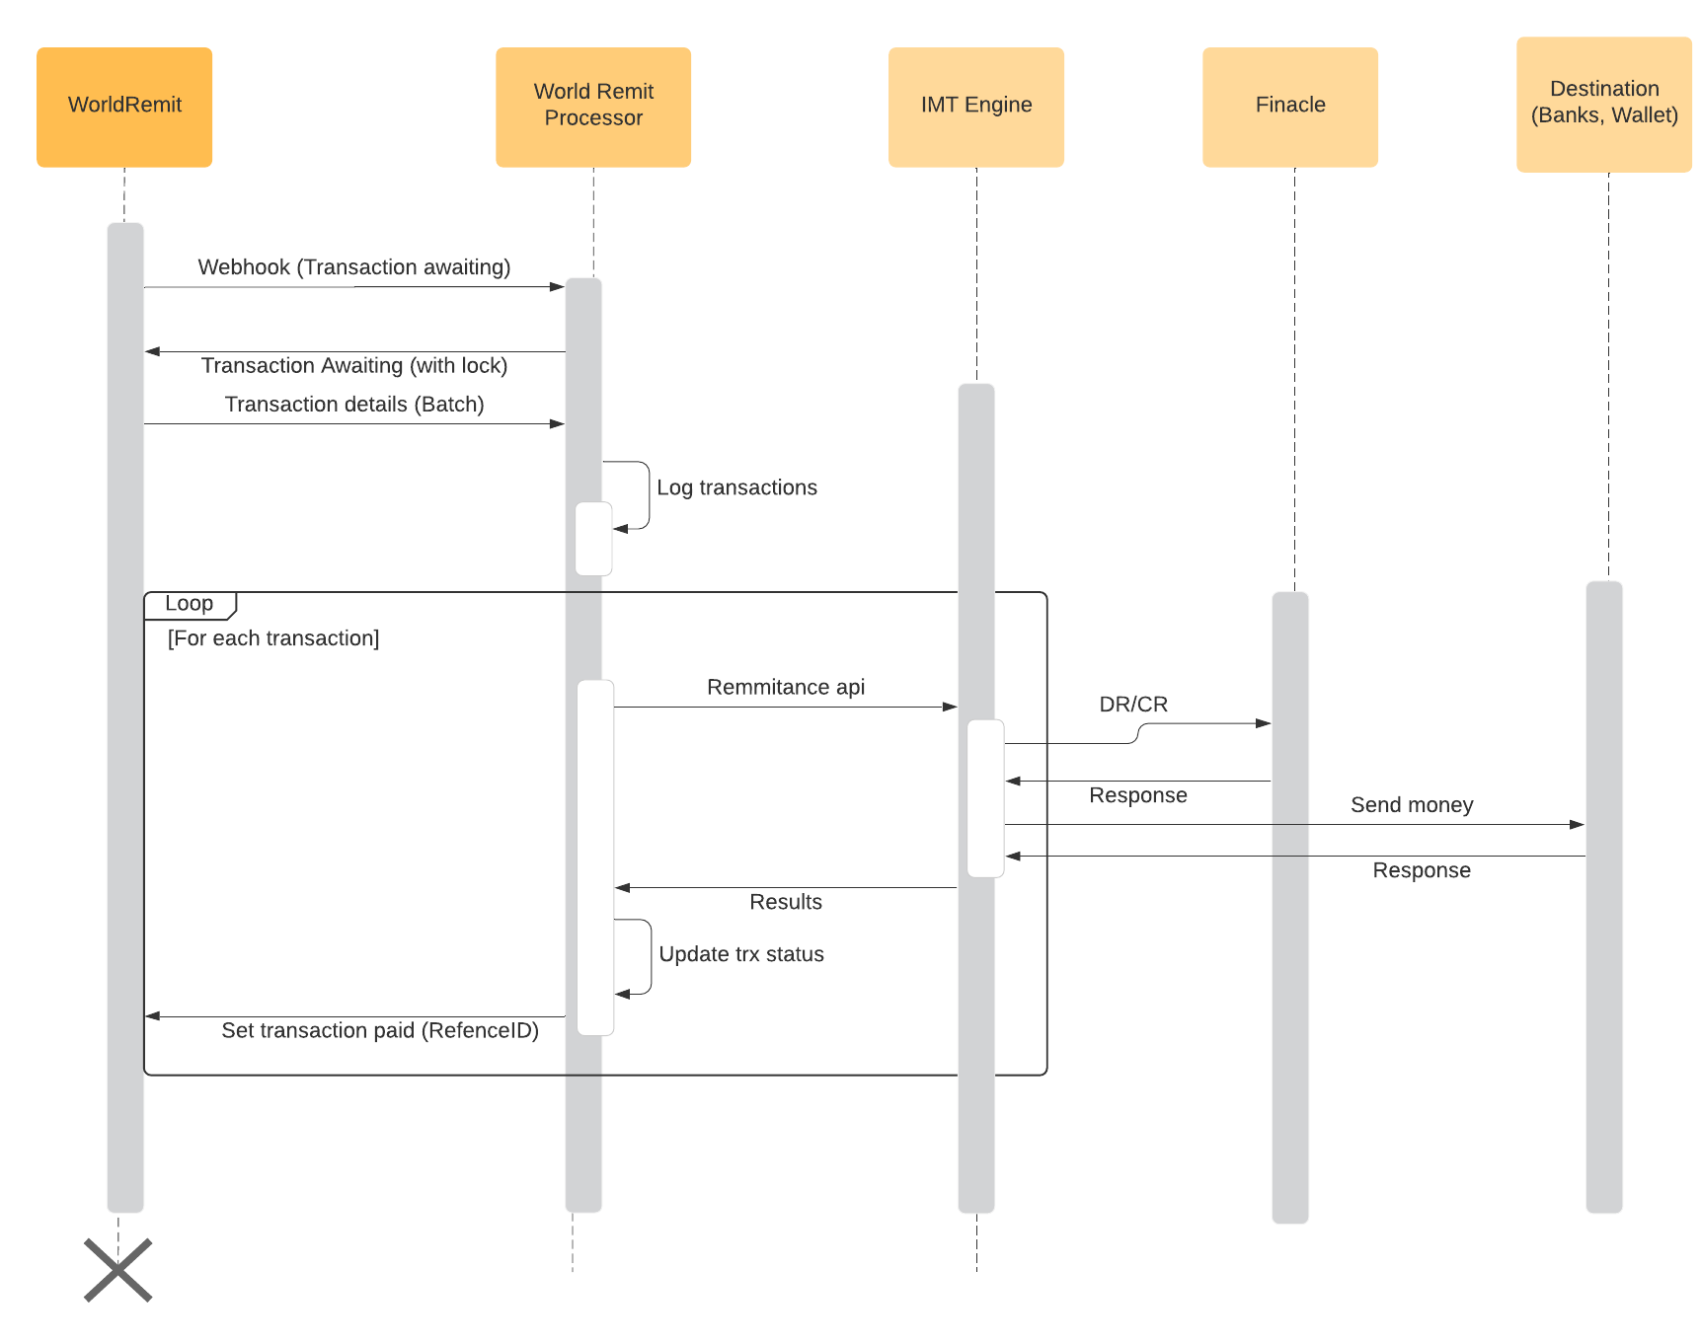
Sequence flow description
- WorldRemit will receive transactions from their customers. They will notify Equity’s WorldRemit processor on new transactions that are available for processing
- Equity WR processor will request transaction details from WR via Transaction Awaiting API call. See the API details in the next section. This will pull a predefined number of transactions in batch. The batch size will be a configuration item so that it can be adjusted as per requirement.
- WR will provide the transactions and mark them as locked so that they cannot be pulled on subsequent Transaction Awaiting API call.
- WR processor will log these transactions in a database with a status ‘New’. See data architecture section for table structure. For performance purposes, the transactions can be pushed to both a messaging queue and the database.
- WR processor will then loop through the new transactions and call IMT remittance API on GAG. The mapping for WR transaction and Remittance API is covered in the mapping section. When using a queue implementation, this process will be listening to the transaction queue. When transactions come in a process listing on this queue will call Remittance api on GAG, acknowledge back to the queue manager and also update the status in the DB with status from Remittance API.
- WR processor will call transaction set paid/failed API on WR sending the status. The specification for the transaction set paid/failed API is also provided in this document. Response codes and messages from Remittance API will have to be mapped back to WR transaction set paid/failed response codes

Webhook specification

Webhook registration
WR processor will register the webhook to receive notifications from WR using below parameters.
Note that we are only subscribing to TransactionStart notifications. Other notification types will be done later.
Item | Description
HTTP Method | POST
URL | https://payoutapi-test.tst.worldremit.com/v2/payoutapi/webhook
Message body | See below

Input parameters
Tag | Data Type | Required | Description
Type | String | Y | Defines type of notification to subscribe to
Endpoint | String | Y | http endpoint for the webhook callback
HttpsIgnoreCertificateErrors | Boolean | Y | Indicates whether to ignore SSL errors
HttpsMutualSSLSignOutgoingRequest | Boolean | Y | Indicates whether 2-way SSL is applicable
EndPointAppendMode | String | Y | Indicates how the notification type will be included in the URL. Will use AppendAsQuery to get as query param  e.g  https://mybank.com/callback?worldremitaction=2’
RefenceID | String | Y | Identifier for this request
CorrespondentIDs |  |  | WR will generate a unique CorrespondentID, which will be shared with Equity Bank
DebounceInMS |  |  | WR internal use
Broadcast |  |  | WR internal use

Output parameters
Tag | Data Type | Required | Description

Sample request
{
"Type": "TransactionStart",
"Endpoint": "https://mybank.com/dosomething?type=TransactionStart",
"HttpsIgnoreCertificateErrors": false,
"HttpsMutualSSLSignOutgoingRequest": false,
"EndpointAppendMode": "AppendToUrl",
"ReferenceId": "eaee13de-0db0-4cd1-adb0-68acb85002cf",
"Name": "WebHook TransactionStart ",
"DebounceInMs": 500,
"CorrespondentIds": [
"7399ac0c-e581-4f36-9029-e43b462db530",
"915d7207-1ba1-4828-afc3-455b6175b809"
],
"Broadcast": true
}

Sample response
{
"Type": "TransactionStart, TransactionCancel",
"Endpoint": "https://mybank.com/dosomething?type=TransactionStart",
"HttpsIgnoreCertificateErrors": false,
"HttpsMutualSSLSignOutgoingRequest": false,
"EndpointAppendMode": "AppendToUrl",
"ReferenceId": "eaee13de-0db0-4cd1-adb0-68acb85002cf",
"Name": "WebHook TransactionStart, TransactionCancel",
"DebounceInMs": 500,
"CorrespondentIds": [
"7399ac0c-e581-4f36-9029-e43b462db530",
"915d7207-1ba1-4828-afc3-455b6175b809"
],
"Broadcast": true
}

Webhook calls to Equity
WR will call WR processor using a webhook registered in earlier step. WR will append notification type at the end of the URL as a query parameter. E.g https://mybank.com/callback?worldremitaction=2’
Value 2 means TransactionStart notification. This will signal WR processor to pull (Transaction Await API) transactions from WR

Transaction awaiting API specification
Note: All calls to WR will require a JWT token as a bearer. This will be passed on the request header

This API pulls transaction that are awaiting processing by Equity bank.
Input parameters
Tag | Data Type | Required | Description
lockTransaction | Boolean | Y | Indicates whether to lock transaction once pulled. This is to avoid pulling same requests
products | Collection | Y | Passed as empty {}
correspondentId | String |  | Not in use. Pass blank “”
Top | Integer | Y | Indicates number of trxs to pull
Skip | Integer | Y | Use zero (0)
batchId | String | Y | Uniquely identifies the batch number

Output parameters
Note: Most of this fields are not required for internal use. See WR API and IMT Remittance API mapping.
Field Name | Description
{
WorldRemitId: 2003261242470006.0, | WorldRemit Internal ID
"ReferenceUnified": "2003261242470006",
"Reference": "2003261242470006", | Transaction Number
"ApiReference": "2003261242470006", | Internal API Transaction Ref
"ThirdpartyReference": "TPRd189540d", | Integrated correspondent transaction reference
"CashPickupReference": null, | Id for picking up cash transfer
"PayoutReference": null, | Reference (Not used by any correspondent)
"ProductCode": "BankTransfer", | Product Code
"ProductCodeText": "BankTransfer", | Product Description
"Status": "Created", | Status of the Transaction
"StatusText": "WARNING: THIS IS A TEST TRANSACTION - DO NOT PROCESS FOR PAYMENT", | Status - Details Message
"CorridorDetail": {
"SenderCountryName": "United States", | Sender Country Name
"SenderCountryCode": "USA", | Sender Country Code
"SenderCountryCodeIso2": "US", | Sender Country ISO Code
"SenderCountryDialCode": "1", | Sender Country Dialling Code
"SenderCurrencyCode": "USD", | Sender Currency Code
"SenderCurrencyNumericCode": 1,
"RecipientCountryCode": "MEX", | Receipient Country Code
"RecipientCountryCodeIso2": "MX", | Receipient Country ISO Code
"RecipientCurrencyCode": "MXN", | Receipient Currency Code
"RecipientCountryDialCode": "52", | Receipient Country Dialling Code
"SettlementCurrencyCode": "GBP", | Settlement Currency Code
"SettlementCurrencyCodeIso2": "GB", | Settlement Currency ISO Code
"ApiCode": null | Used internally only
},
"CorrespondentId": null, | Correspondent Unique ID. Will be generated by WR (Not used by any correspondent)
"CorrespondentDetail": {
"Id": 1, | Correspondent details Id
"ApiId": 2, | Correspondent API ID
"AgentCode": "", | Used internally only
"SubAgentCode": null,
"Name": "FakeCorr", | Correspondent NAME
"ApiName": "FakeAPIV2", | Correspondent API NAME
"OfficeId": 1,
"CorrespondentCountryId": 1, | WorldRemit Internal Country Id
"CorrespondentCountry": "MEX", | Correspondent Country Code
"RequiresReferenceUpdate": false, | Correspondent configuration property set in internal WR system (for internal use)
"ReferenceDelimiter": "X" | Correspondent configuration property set in internal WR system (for internal use)
},
"FinancialDetail": {
"SenderAmount": 8932, | Sender Amount.
"FxRateSenderToBeneficiaryCurrency": 19, | FX Rate from Sender to Beneficiary
"FxRateSenderToSettlementCurrency": 1, | FX Rate from Sender for Settlement Purpose
"SenderFees": 4573, | Sender Fees (if any) from WR
"SenderFeeDiscount": 0, | Sender Fee Discount - Offered by WR (if any)
"SenderOtherFees": 0, | Sender Other Fees (If any)
"SenderAdditionalCharges": 0, | Sender Additional Charges (if any)
"SenderTotalPaid": 14336, | Total Amount Paid by the Sender.
"BeneficiaryAmount": 185497, | Beneficiary Amount
"BeneficiaryCharges": 0, | Beneficiary Charges (if any)
"BeneficiaryTotalReceived": 185497, | Beneficiary Amount - This is the amout paid to the Beneficiary ie (BeneficiaryAmount - BeneficiaryCharges)
"FxRateSettlementToBeneficiaryCurrency": 17, | FX Rate for Settlement to Beneficiary Currency
"SettlementAmount": 9763, | Settlement Amount
"SettlementCommissionAmount": 1371.9 | Settlement Commission Amount
},
"SenderDetail": {
"Id": 0, | Sender Id
"CustomerReference": "WR874caa8e", | WR Customer Reference
"ReasonCode": "Purchase of services", | Reason for sending money
"ReasonDescription": "Bill payments", | Description of the Reason
"FirstName": "Matt", | Sender First Name of
"MiddleName": "J.", | Sender Middle Name
"LastName": "Smith", | Sender Last Name
"MobilePhone": "5551234567", | Sender Mobile Phone Number
"LandlinePhone": "5551234567", | Sender Landline Number
"Email": "WR874caa8e@NOTREALEMAIL.com", | Sender Email Id
"AddressDetail": {
"AddressLine1": "Fake Street 123", | Sender Address Line 1
"AddressLine2": "Fake Apt 5", | Sender Address Line 2
"AddressLine3": "Under the cupboard", | Sender Address Line 3
"Suburb": "Denver South", | Sender Suburb
"Region": "Downtown", | Sender Region
"PostalCode": "80222", | Sender Postal Code
"City": "Denver", | Sender City
"Country": "USA", | Sender Country
"State": "CO" | Sender State
},
"Gender": "M", | Sender Gender
"IdentificationType": "Drivers License", | Sender ID Type
"IdentificationNumber": "ID-d5acb9e6", | Sender ID Number
"IdentificationExpiryDate": "2022-03-26T00:00:00+00:00", | Sender ID Expiry Date
"SocialSecurityNumber": null, | Sender Social Secuirty Number
"DateOfBirth": "1992-03-26T00:00:00+00:00" | Sender Date of Birth
},
"RecipientDetail": {
"Id": 1, | Recipient ID
"InternalReference": "WR000001", | Recipient Ref number (generated by WR)
"MobileAccountNumber": "5551234567", | Recipient Mobile Number
"SecretQuestion": "What is life?", | Recipient Secret Question
"SecretAnswer": "42", | Recipient Secret Answer
"FirstName": "John", | Recipient First Name
"MiddleName": "M.", | Recipient Middle Name
"LastName": "Doe", | Recipient Last Name
"MobilePhone": "5551234567", | Recipient Mobile Number
"LandlinePhone": "5551234567", | Recipient Land Line
"Email": "WR000001@NOTREALEMAIL.com", | Recipient Email ID
"AddressDetail": {
"AddressLine1": "Other Street 123", | Recipient Address Line 1
"AddressLine2": "Other Apt 5", | Recipient Address Line 2
"AddressLine3": "...", | Recipient Address Line 3
"Suburb": "Valle Dorado", | Recipient Suburb
"Region": "Baja", | Recipient Region
"PostalCode": "92133", | Recipient Postal Code
"City": "Ensenada", | Recipient City
"Country": "MEX", | Recipient Country Code
"State": "BC" | Recipient State
},
"Gender": "M", | Recipient Gener
"IdentificationType": "Passport", | Recipient ID description
"IdentificationNumber": "1234567890", | Recipient ID number
"IdentificationExpiryDate": "2022-03-26T00:00:00+00:00", | Recipient ID Expiry Date
"SocialSecurityNumber": null, | Recipient Social Secuirty Number
"DateOfBirth": "1992-03-26T00:00:00+00:00" | Recipient Date of Birth
},
"BankDetail": {
"Id": 1, | Bank detail ID
"BankCode": "10000000", | Recipient Bank Code
"BankName": "Bundesbank", | Recipient Bank Name
"AccountNumber": "12345678", | Recipient Account Number
"AccountTypeCode": null, | Recipient Account Type Code
"IBAN": "DE93100000000012345678", | Recipient IBAN Number
"BIC": "123456", | Recipient BIC Code
"BranchCode": "FAKEBANKBRANCH1", | Recipient Bank Branch Code
"BranchName": "Fake Bank Branch", | Recipient Bank Branch Name
"BranchCity": "Tijuana", | Recipient Bank City
"BranchState": "Berlin", | Recipient Bank State
"AgentCodeOverride": "",
"AgentSubCodeOverride": "",
"AccountType": "Checks", | Recipient Account Type Description
"TokenId": "1111222233334444",
"ObfuscatedPAN": null | Displaying partially encrypted data (Used internally only)
},
"Events": {
"CreationDate": "2020-03-26T09:42:47.8356286+00:00", | Trn Created DateTime
"AuthorizationDate": "2020-03-26T10:42:47.8356315+00:00", | Trn Authorised DateTime
"TransmitDate": null, | Used internally only
"PayoutDate": null, | Used internally only
"ApiCancellationRequestDate": null, | Used internally only
"ApiBeneficiaryChangeDate": null, | Used internally only
"CancellationDate": null, | Used internally only
"ApiErrorRetryCount": 0, | Used internally only
"VoidDate": null | Used internally only
},
"Properties": {},
"BeneficiaryChangeState": "None", | Technical property used for validating if a transaction has been changed using the Change Beneficiary functionality. (Used internally only)
"Signature": null, | Hash of the payload with the cert
"Id": "2b8bf9de-f081-49c5-aa30-23d1577c830d", | Transaction Id
"VersionId": "88ec2e3f-e478-465c-aaed-6bbd164a0d37", | Version Id
"UserIdReference": null, | User Id reference (Internal use)
"DateCreated": "2020-03-26T12:42:47.8356101+00:00", | Date created
"DateUpdated": null, | Date updated
"DateLastRecorded": "2020-03-26T12:42:47.8356101+00:00" | Date last modified
}

Sample request
{
"lockTransaction": true,
"products": {},
"correspondentId": "232323",
"top": 50,
"skip": 0,
"batchId": "13232"
}

Sample response
{
"correspondentId": "string",
"content": [
{
"isRetry": true,
"transaction": {
"WorldRemitId": 2003261242180004.0,
"ReferenceUnified": "2003261242180004",
"Reference": "2003261242180004",
"ApiReference": "2003261242180004",
"ThirdpartyReference": "TPRa365d6f2",
"CashPickupReference": null,
"PayoutReference": null,
"ProductCode": "BankTransfer",
"ProductCodeText": "BankTransfer",
"Status": "Created",
"StatusText": "WARNING: THIS IS A TEST TRANSACTION - DO NOT PROCESS FOR PAYMENT",
"CorridorDetail": {
"SenderCountryName": "United States",
"SenderCountryCode": "USA",
"SenderCountryCodeIso2": "US",
"SenderCountryDialCode": "1",
"SenderCurrencyCode": "USD",
"SenderCurrencyNumericCode": 1,
"RecipientCountryCode": "MEX",
"RecipientCountryCodeIso2": "MX",
"RecipientCurrencyCode": "MXN",
"RecipientCountryDialCode": "52",
"SettlementCurrencyCode": "GBP",
"SettlementCurrencyCodeIso2": "GB",
"ApiCode": null
},
"CorrespondentId": null,
"CorrespondentDetail": {
"Id": 1,
"ApiId": 2,
"AgentCode": "",
"SubAgentCode": null,
"Name": "FakeCorr",
"ApiName": "FakeAPIV2",
"OfficeId": 1,
"CorrespondentCountryId": 1,
"CorrespondentCountry": "MEX",
"RequiresReferenceUpdate": false,
"ReferenceDelimiter": "X"
},
"FinancialDetail": {
"SenderAmount": 8298,
"FxRateSenderToBeneficiaryCurrency": 17,
"FxRateSenderToSettlementCurrency": 1,
"SenderFees": 7599,
"SenderFeeDiscount": 0,
"SenderOtherFees": 0,
"SenderAdditionalCharges": 0,
"SenderTotalPaid": 12747,
"BeneficiaryAmount": 87516,
"BeneficiaryCharges": 0,
"BeneficiaryTotalReceived": 87516,
"FxRateSettlementToBeneficiaryCurrency": 17,
"SettlementAmount": 5148,
"SettlementCommissionAmount": 2279.7
},
"SenderDetail": {
"Id": 0,
"CustomerReference": "WR8a8b695d",
"ReasonCode": "Purchase of services",
"ReasonDescription": "Bill payments",
"FirstName": "Matt",
"MiddleName": "J.",
"LastName": "Smith",
"MobilePhone": "5551234567",
"LandlinePhone": "5551234567",
"Email": "WR8a8b695d@NOTREALEMAIL.com",
"AddressDetail": {
"AddressLine1": "Fake Street 123",
"AddressLine2": "Fake Apt 5",
"AddressLine3": "Under the cupboard",
"Suburb": "Denver South",
"Region": "Downtown",
"PostalCode": "80222",
"City": "Denver",
"Country": "USA",
"State": "CO"
},
"Gender": "M",
"IdentificationType": "Drivers License",
"IdentificationNumber": "ID-4c9dcecb",
"IdentificationExpiryDate": "2022-03-26T00:00:00+00:00",
"SocialSecurityNumber": null,
"DateOfBirth": "1992-03-26T00:00:00+00:00"
},
"RecipientDetail": {
"Id": 1,
"InternalReference": "WR000001",
"MobileAccountNumber": "5551234567",
"SecretQuestion": "What is life?",
"SecretAnswer": "42",
"FirstName": "John",
"MiddleName": "M.",
"LastName": "Doe",
"MobilePhone": "5551234567",
"LandlinePhone": "5551234567",
"Email": "WR000001@NOTREALEMAIL.com",
"AddressDetail": {
"AddressLine1": "Other Street 123",
"AddressLine2": "Other Apt 5",
"AddressLine3": "...",
"Suburb": "Valle Dorado",
"Region": "Baja",
"PostalCode": "92133",
"City": "Ensenada",
"Country": "MEX",
"State": "BC"
},
"Gender": "M",
"IdentificationType": "Passport",
"IdentificationNumber": "1234567890",
"IdentificationExpiryDate": "2022-03-26T00:00:00+00:00",
"SocialSecurityNumber": null,
"DateOfBirth": "1992-03-26T00:00:00+00:00"
},
"BankDetail": {
"Id": 1,
"BankCode": "10000000",
"BankName": "Bundesbank",
"AccountNumber": "12345678",
"AccountTypeCode": null,
"IBAN": "DE93100000000012345678",
"BIC": "123456",
"BranchCode": "FAKEBANKBRANCH1",
"BranchName": "Fake Bank Branch",
"BranchCity": "Tijuana",
"BranchState": "Berlin",
"AgentCodeOverride": "",
"AgentSubCodeOverride": "",
"AccountType": "Checks",
"TokenId": "1111222233334444",
"ObfuscatedPAN": null
},
"Events": {
"CreationDate": "2020-03-26T09:42:18.3658613+00:00",
"AuthorizationDate": "2020-03-26T10:42:18.3658644+00:00",
"TransmitDate": null,
"PayoutDate": null,
"ApiCancellationRequestDate": null,
"ApiBeneficiaryChangeDate": null,
"CancellationDate": null,
"ApiErrorRetryCount": 0,
"VoidDate": null
},
"Properties": {},
"BeneficiaryChangeState": "None",
"Signature": null,
"Id": "4eadee31-144e-4467-874a-9cb520787c98",
"VersionId": "8e6094eb-f0b6-438e-b1e3-f5a5a86ec442",
"UserIdReference": null,
"DateCreated": "2020-03-26T12:42:18.3658342+00:00",
"DateUpdated": null,
"DateLastRecorded": "2020-03-26T12:42:18.3658342+00:00"
}
}
],
"count": 0,
"top": 0,
"skip": 0,
"batchId": "string",
"traceId": "string"
}

WorldRemit and IMT remittance API mapping

WordRemit (WR) |  |  | IMT Engine
Tag | Type | Notes | Source Service Tag | Data Type | Length | Variable Length | Mand  /Opt | Description  Default/Expected Values
BankDetail.AccountNumber | String |  | AccountNumber | String/text | 13 | Y | M | Beneficiary Bank Account Number
Transaction.WorldRemitId | Integer |  | PaymentReference1 | String/text | 100 | Y | M | Payment reference number e.g. Unique Transaction code/Reference. This field will be used to reconcile and batch proofing.
ReciepientDetail.FirstName + MiddleName + LastName | String | Concatenate the names with spacing between the names | PaymentReference2 | String/text | 100 | Y | M | Additional Payment reference e.g. Beneficiary Name or the Account Name
Transcation.reference | String |  | PaymentReference3 | String/text | 100 | Y | M | Additional Payment reference e.g. Sender details or source transaction reference number
 |  | To be provided by GAG | PaymentType | Lookup | 50 | Y | M | Static - The name of the remmitance agent e.g FUNTECH
 |  |  | Remarks | String/text | 100 | Y | O | The detail of the recipient of the funds i.e. the name of the beneficiary or the name of the account where money will be credited.
 |  | To be assigned by GAG | AgentID | Number | 10 | Y | M | A unique number to used to identify the paying account (to be shared)
 |  | To be calculated by WR processor | Check | String/text | 200 | Y | M | This field is a checksum. The transaction acquiring organization/agent will sign this field with their private Key. First the following fields are concatenated. (SALT + (AccountNumber +BIC) or (Wallet +Mobile Number) )+ paymentReference1+ paymentType+ agentID+ tranAmount+ currencyCode+messageID) in that order (Salt to be shared) (Mandatory). The resulting text is then signed with Private Key and Base64 encoded.(Mandatory)
 |  |  | Data | String/text | 200 |  | O | Not used for now(Future use)
MessageID | String | This is generated by WR processor. It has to be unique per call | MessageID | String/text | 100 |  | M | A unique number for every call to the web service
 |  |  | Fees | Float | - |  | M | Not used for now (Future use) default to Zero
See comments | String | To be derived from CorridorDetail.RecipientCountryCodeIso2 | InstCode | String/text | 20 |  | M | For Kenya use 54, Uganda 56 , Tanzania 55, Rwanda 50 and South Sudan 11
CorridorDetail. SettlementCurrencyCodeIso2 | String |  | CurrencyCode | String/text | 3 | N | M | The ISO currency code of the transaction Amount
CorridorDetail.RecipientCountryCodeIso2 | String | M | CountryCode | String/text | 2 | N | M | Destination country code as defined by ISO 3166
BankDetail.BIC | String | Confirm this | BicCode | String/text | 50 | Y | O | Destination Bank Swift Bic code. For transactions to be remitted to other banks
RecipientDetail.MobileAccountNumber | String |  | MobileNumber | String/text | 12 | N | O | In case funds are remitted to a Telkom Wallet recipient Mobile number
 |  | Which field to use?? | WalletName | String/text | 50 | Y | O | An identifier to identify Telcom Wallet
 |  |  | BankCode | String/text | 5 |  | O | Not Used now
 |  |  | BranchCode | String/text | 5 |  | O | Not Used Now
SenderDetail.FirstName + MiddleName+ LastName | String | Concatenate the 3 names | SenderName | String/text | 100 | Y | O | A sender name is required for SMS Notification
FinancialDetail.SettlementAmount | String |  | TransAmount | float | - |  | M | Transaction Amount

Transaction set paid specification
WR processor will call WR once the request has been processed by IMT Engine. It will call WR to update the status as paid for specific transaction reference.

Request parameters
Tag | Data Type | Required | Description
TrxnReference | String | Y | Transaction reference from core banking system – Yes that is correct.
ValidationCode | String |  | Not in use – you can ignore this field.
OfficeId | String |  | Not in use – you can ignore this field.
BeneficiaryIdExpiryDate | String |  | Receiver ID expiry (pick from transactions logged after transaction awaiting api)
BeneficiaryIdNumber | String |  | Receiver id number. To be retrieved as field above
BeneficiaryIdType | String |  | Receiver id type
BeneficiaryIdPlaceOfIssue | String |  | Place of issue of the ID
ActualSettlementAmount | String |  | Settlement amount
ActualFxRateSettlementToBeneficiaryCurrency | String
ActualCommissionInSettlementCurrency | String
ResponseCode | String |  | IMT remittance API response code
ResponseMessage | String |  | Response message
Comment | String
CashPickupReference | String |  | Null.
CorrespondentFxRateSettlementToBeneficiaryCurrency | String |  | Currency used to settle receiver
CorrespondentSettlementCommissionAmount | Decimal
CorrespondentSettlementAmount | String
CorrespondentBeneficiaryTotalReceived | Decimal
validationcode | String
beneficiaryidnumber | String
beneficiaryidtype | String
beneficiaryidplaceofissue | String
beneficiaryidexpirydate | String

For most fields, except validationCode, OfficeId and trxReference, the details will be pulled from already saved transaction detail after transaction awaiting api call to WR. Remember that once transaction awaiting api is called and transactions have been pulled by WR processor, the details will be saved into a DB table as per the data structure covered in data architecture section.
This is a PUT http request that takes parameters in the URL and also contains the body of the status
- URL sample: https://payoutapi-test.tst.worldremit.com/v2/payoutapi/transaction/set/paid[?wrid][&reference]

Sample request
{
"ValidationCode": "1239402",
"OfficeId": null,
"BeneficiaryIdExpiryDate": "1970-01-01T00:00:00+00:00",
"BeneficiaryIdNumber": "GB2939390R",
"BeneficiaryIdType": "ID Card",
"BeneficiaryIdPlaceOfIssue": "Barnsley UK",
"ActualSettlementAmount": null,
"ActualFxRateSettlementToBeneficiaryCurrency": null,
"ActualCommissionInSettlementCurrency": null,
"ResponseCode": null,
"ResponseMessage": null,
"Comment": null,
"TxnReference": null,
"CashPickupReference": null,
"CorrespondentFxRateSettlementToBeneficiaryCurrency": null,
"CorrespondentSettlementCommissionAmount": null,
"CorrespondentSettlementAmount": null,
"CorrespondentBeneficiaryTotalReceived": null,
"ExtensionData": {},
"Properties": {
"validationcode": "1239402",
"beneficiaryidnumber": "GB2939390R",
"beneficiaryidtype": "ID Card",
"beneficiaryidplaceofissue": "Barnsley UK",
"beneficiaryidexpirydate": "1970-01-01T00:00:00+00:00"
}
}

Sample response
There is no response payload. WR will respond with HTTP codes. Below are the response codes
Response code | Description
200 | Transaction has been marked as paid
500 | Internal server error
400 | Bad request
401 | Unauthorized
403 | Forbidden
404 | Not found
412 | Precondition failed
901 | 901 Invalid request passed.
905 | Invalid identification type
923 | Invalid beneficiary identification number
210 | Required request property not set.
605 | Transaction state cannot be retrieved.
606 | A response code value is a required parameter for this state and has not been set
607 | The response code value supplied is not valid for the state requested. Please contact WorldRemit operation support staff
700 | Invalid transaction
701 | Cannot retrieve transaction state history

The IMT Remittance API response codes and response description needs to be mapped back to WR response codes. Below is the mapping.
This api will only be used when a transaction has successfully been paid. Otherwise, use transaction set failed should be used.
WorldRemit |  | IMT Remittance API
Response code | Description | Code | Message
200 | Transaction has been marked as paid | 000 | Transaction approved

Transaction set failed
WR processor will call WR once the request has been processed by IMT Engine. It will call WR to update the status as failed for a specific transaction.
This is a PUT http request that takes parameters in the URL and also contains the body of the status
- URL sample: https://payoutapi-test.tst.worldremit.com/v2/payoutapi/transaction/set/failed[?wrid][&reference

Sample request (Ignore this)
{
"properties": {}
}

You should use Set Paid and Set Response, instead of Set Failed and Acknowledged.
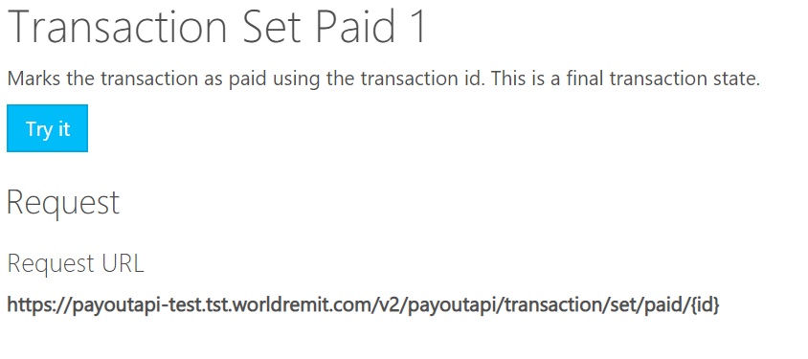

Sample response
There is no response payload. WR will respond with HTTP codes. Below are the response codes
Response code | Description
200 | Transaction has been marked as failed
500 | Internal server error
400 | Bad request
401 | Unauthorized
403 | Forbidden
404 | Not found
412 | Precondition failed
210 | Required request property not set.
605 | Transaction state cannot be retrieved.
606 | A response code value is a required parameter for this state and has not been set
607 | The response code value supplied is not valid for the state requested. Please contact WorldRemit operation support staff
700 | Invalid transaction
701 | Cannot retrieve transaction state history

Data architecture
Below is the table that will store transactions as they are pulled from WorldRemit. The status of this table will be updated as the transaction progress through the various systems.
Field Name | Type | Description
WorldRemitId | Int | WorldRemit Internal ID
ReferenceUnified | String
Reference | String | Transaction Number
ApiReference | String | Internal API Transaction Ref
ThirdpartyReference | String | Integrated correspondent transaction reference
CashPickupReference | String | Id for picking up cash transfer
PayoutReference | String | Reference (Not used by any correspondent)
ProductCode | String | Product Code
ProductCodeText | String | Product Description
Status | String | Status of the Transaction
StatusText | String | Status - Details Message
CorridorDetail
SenderCountryName | String | Sender Country Name
SenderCountryCode | String | Sender Country Code
SenderCountryCodeIso2 | String | Sender Country ISO Code
SenderCountryDialCode | String | Sender Country Dialling Code
SenderCurrencyCode | String | Sender Currency Code
SenderCurrencyNumericCode | String
RecipientCountryCode | String | Receipient Country Code
RecipientCountryCodeIso2 | String | Receipient Country ISO Code
RecipientCurrencyCode | String | Receipient Currency Code
RecipientCountryDialCode | String | Receipient Country Dialling Code
SettlementCurrencyCode | String | Settlement Currency Code
SettlementCurrencyCodeIso2 | String | Settlement Currency ISO Code
ApiCode | String | Used internally only
CorrespondentId | String | Correspondent Unique ID. Will be generated by WR (Not used by any correspondent)
CorrespondentDetail | String
Id | String | Correspondent details Id
ApiId | String | Correspondent API ID
AgentCode | String | Used internally only
SubAgentCode | String
Name | String | Correspondent NAME
ApiName | String | Correspondent API NAME
OfficeId | String
CorrespondentCountryId | String | WorldRemit Internal Country Id
CorrespondentCountry | String | Correspondent Country Code
RequiresReferenceUpdate | String | Correspondent configuration property set in internal WR system (for internal use)
ReferenceDelimiter | String | Correspondent configuration property set in internal WR system (for internal use)
SenderAmount | Decimal | Sender Amount.
FxRateSenderToBeneficiaryCurrency | Integer | FX Rate from Sender to Beneficiary
FxRateSenderToSettlementCurrency | Integer | FX Rate from Sender for Settlement Purpose
SenderFees | Decimal | Sender Fees (if any) from WR
SenderFeeDiscount | Decimal | Sender Fee Discount - Offered by WR (if any)
SenderOtherFees | Decimal | Sender Other Fees (If any)
SenderAdditionalCharges | Decimal | Sender Additional Charges (if any)
SenderTotalPaid | Decimal | Total Amount Paid by the Sender.
BeneficiaryAmount | Decimal | Beneficiary Amount
BeneficiaryCharges | Decimal | Beneficiary Charges (if any)
BeneficiaryTotalReceived | Decimal | Beneficiary Amount - This is the amout paid to the Beneficiary ie (BeneficiaryAmount - BeneficiaryCharges)
FxRateSettlementToBeneficiaryCurrency | Decimal | FX Rate for Settlement to Beneficiary Currency
SettlementAmount | Decimal | Settlement Amount
SettlementCommissionAmount | Decimal | Settlement Commission Amount
SenderId | Integer | Sender Id
SenderCustomerReference | String | WR Customer Reference
SenderReasonCode | String | Reason for sending money
SenderReasonDescription | String | Description of the Reason
SenderFirstName | String | Sender First Name of
SenderMiddleName | String | Sender Middle Name
SenderLastName | String | Sender Last Name
SenderMobilePhone | String | Sender Mobile Phone Number
SenderLandlinePhone | String | Sender Landline Number
SenderEmail | String | Sender Email Id
SenderAddressLine1 | String | Sender Address Line 1
SenderAddressLine2 | String | Sender Address Line 2
SenderAddressLine3 | String | Sender Address Line 3
SenderSuburb | String | Sender Suburb
SenderRegion | String | Sender Region
SenderPostalCode | String | Sender Postal Code
SenderCity | String | Sender City
SenderCountry |  | Sender Country
SenderState |  | Sender State
SenderGender |  | Sender Gender
SenderIdentificationType |  | Sender ID Type
SenderIdentificationNumber |  | Sender ID Number
SenderIdentificationExpiryDate |  | Sender ID Expiry Date
SenderSocialSecurityNumber |  | Sender Social Secuirty Number
SenderDateOfBirth |  | Sender Date of Birth
ReceiverId | Integer | Recipient ID
ReceiverInternalReference | String | Recipient Ref number (generated by WR)
ReceiverMobileAccountNumber | String | Recipient Mobile Number
ReceiverSecretQuestion | String | Recipient Secret Question
ReceiverSecretAnswer | String | Recipient Secret Answer
ReceiverFirstName | String | Recipient First Name
ReceiverMiddleName | String | Recipient Middle Name
ReceiverLastName | String | Recipient Last Name
ReceiverMobilePhone | String | Recipient Mobile Number
ReceiverLandlinePhone | String | Recipient Land Line
ReceiverEmail | String | Recipient Email ID
ReceiverAddressLine1 | String | Recipient Address Line 1
ReceiverAddressLine2 | String | Recipient Address Line 2
ReceiverAddressLine3 | String | Recipient Address Line 3
ReceiverSuburb | String | Recipient Suburb
ReceiverRegion | String | Recipient Region
ReceiverPostalCode | String | Recipient Postal Code
ReceiverCity | String | Recipient City
ReceiverCountry | String | Recipient Country Code
ReceiverState | String | Recipient State
ReceiverGender | String | Recipient Gener
ReceiverIdentificationType | String | Recipient ID description
ReceiverIdentificationNumber | String | Recipient ID number
ReceiverIdentificationExpiryDate | String | Recipient ID Expiry Date
ReceiverSocialSecurityNumber | String | Recipient Social Secuirty Number
ReceiverDateOfBirth | String | Recipient Date of Birth
BankDetailId | Integer | Bank detail ID
BankDetailBankCode | String | Recipient Bank Code
BankDetailBankName | String | Recipient Bank Name
BankDetailAccountNumber | String | Recipient Account Number
BankDetailAccountTypeCode | String | Recipient Account Type Code
BankDetailIBAN | String | Recipient IBAN Number
BankDetailBIC | String | Recipient BIC Code
BankDetailBranchCode | String | Recipient Bank Branch Code
BankDetailBranchName | String | Recipient Bank Branch Name
BankDetailBranchCity | String | Recipient Bank City
BankDetailBranchState | String | Recipient Bank State
BankDetailAccountType | String | Recipient Account Type Description
EventsCreationDate | String | Trn Created DateTime
EventsAuthorizationDate | String | Trn Authorised DateTime
EventsTransmitDate | String | Used internally only
BeneficiaryChangeState | String | Technical property used for validating if a transaction has been changed using the Change Beneficiary functionality. (Used internally only)
Signature | String | Hash of the payload with the cert
Id | String | Transaction Id
VersionId | String | Version Id
DateCreated | String | Date created
DateUpdated | String | Date updated
DateLastRecorded | String | Date last modified

Referenced documents
Document | Description
 | WorldRemit API specification
 | WorldRemit JWT token. Required for calling WR apis

